EXPERIMENT 18
Determination and plotting of Antenna Half power beamwidth.
Aim:
To determine and plot Half Power Beamwidth (HPBW) and to determine the angular width at -3 dB points
Software required:
• SCILAB version 6.0.1
Program:
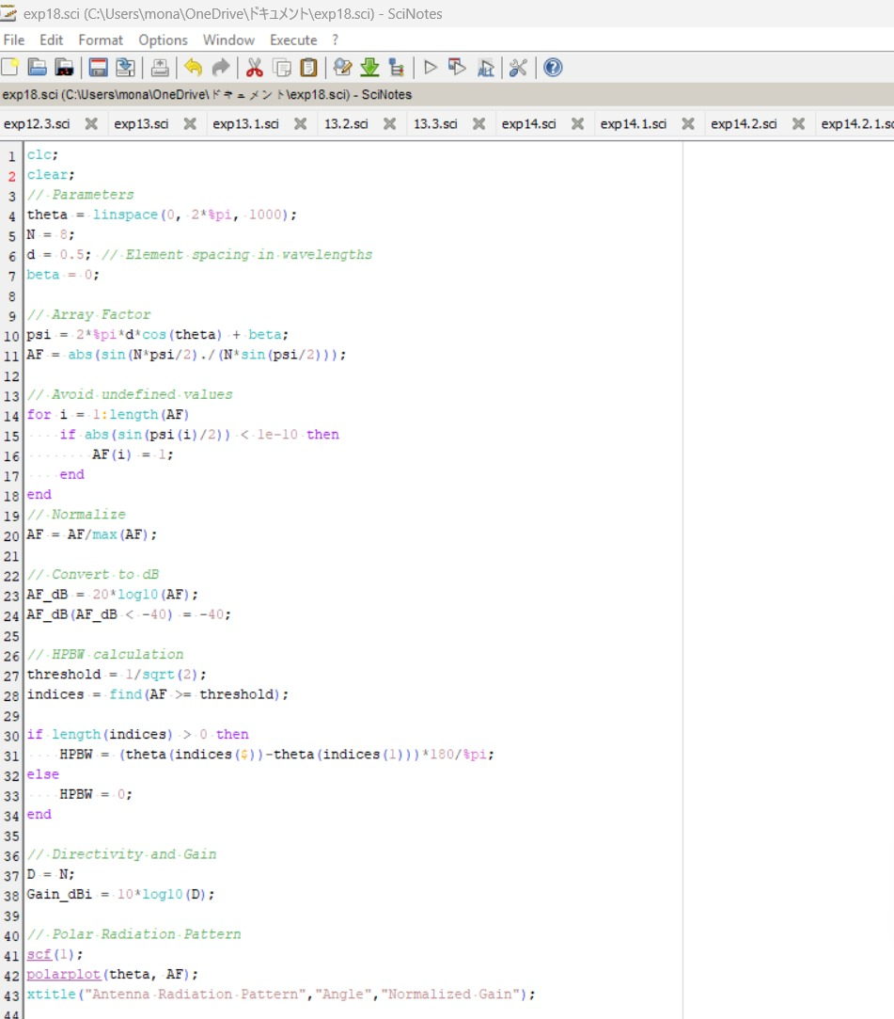
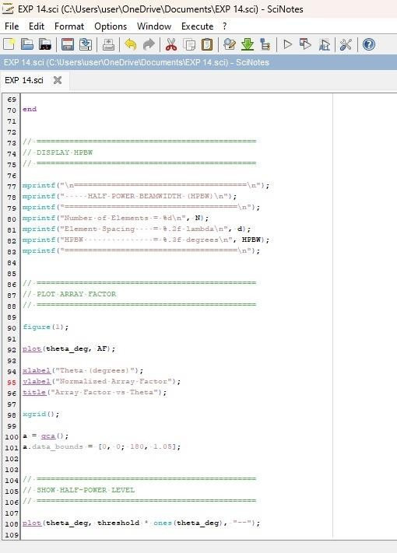
Output:
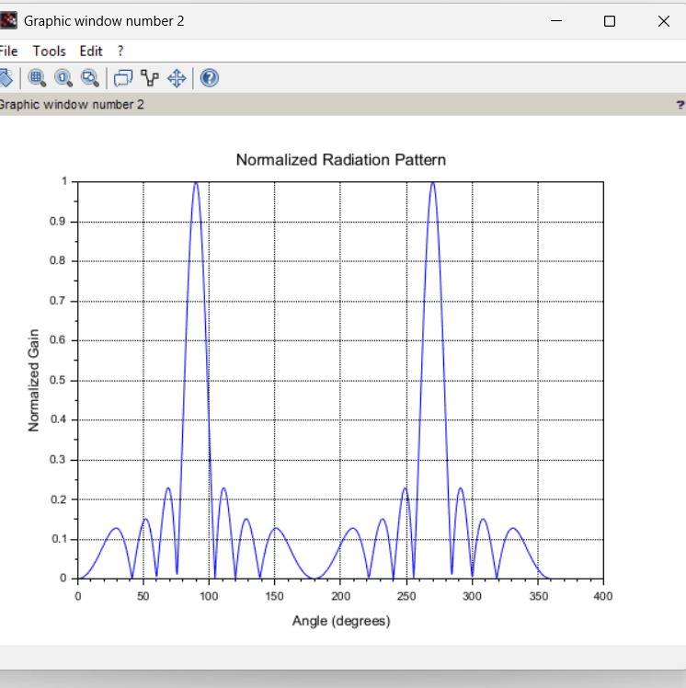

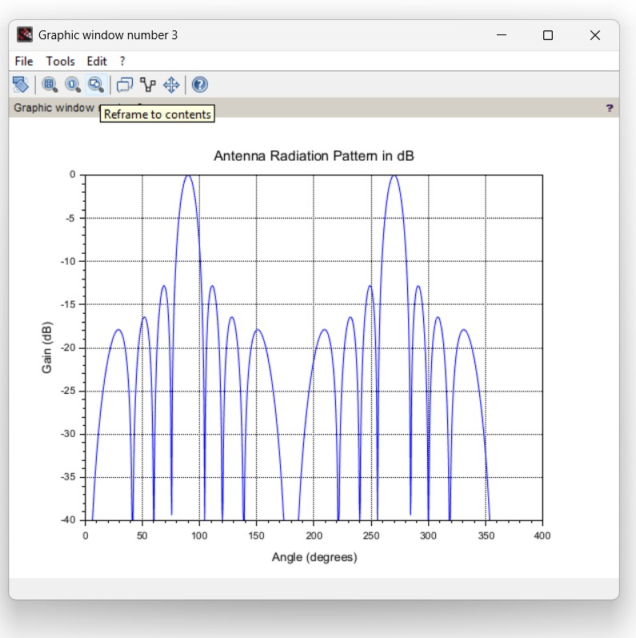
RESULT: The experiment was done and the Half power beamwidth of the given antenna was calculated. Different case studies were done.

